**篇章练习**

Table of Contents

HOW 70

Text 1 71

Text 2 72

Text 3 73

Text 4 74

Text`5 75

Text 6 76

WHY 77

Text 1 78

Text 2 79

Text 3 80

Text 4 81

Text 5 82

Text 6 83

WHAT 84

Text 1 84

Text 2 86

Text 3 87

Text 4 88

Text 5 89

Text 6 90

MIXED 91

Text 1 91

Text 2 93

Text 3 94

Text 4 95

Text 5 96

Text 6 97

Text 7 98

Text 8 99

Text 9 100

Text 10 101

Text 11 102

Text 12 103

Text 13 104

Text 14 105

Text 15 106

Text 16 107

Text 17 108

HOW

Text 1

I. summarize each paragraph in one sentence or phrase

|  |  |
| --- | --- |
| Text | Summary |
| Simple solutions to stubborn problems, especially those that cost lives, are hard to come by. When one of those solutions is within reach, it should be embraced. | - |
| Here’s the issue: Ever more Americans are taking up bicycling as a mode of transportation. From 2000 to 2017, bicycle commuting grew by 43 percent — even more in big cities like New York, Chicago, Washington and Los Angeles. |  |
| This is a good thing. It’s been motivated by a personal desire for exercise and a broader wish to reduce congestion and fossil-fuel use. And it’s been helped along by wise urban design, the creation of bike lanes and bike-share programs. |  |
| All this has come with a cost, though — in bicycle deaths, which hit a dismal decades-long high in 2016 before dropping slightly last year. Among vehicle-to-cycle crashes, among the most injurious are doorings. |  |
| What’s a dooring? That’s the technical term for what happens when a car door crosses a cyclist’s path — when a small, lightweight, fast-moving object comes into contact with a larger, heavier, stationary entity. The effects can be devastating. |  |
| Now for the solution. Remarkably, there is an unheralded, low-cost approach to reducing this sort of accident. It’s called the “Dutch Reach” — for the bike-happy country where it is widely practiced — and it is as simple as its two-syllable name. |  |
| It works like this: When exiting a car, instead of using the nearer hand to open the door, drivers use the farther hand. Reaching across to grab the handle causes them to turn, look backward and, more likely than not, see an oncoming cyclist. It’s the same easy movement used to fasten a seat belt — just in reverse. |  |
| Though there is no precise data on the effect of the technique, it’s fair to say that it has had a meaningful impact on safety. In the Netherlands, where it has been taught for years, cycling deaths have fallen even as ridership has increased. |  |
| The move is beginning to catch on elsewhere. Illinois and Massachusetts recently introduced the concept in their road safety manuals, and it could appear soon on state driving tests. Britain has similar plans. Other states and countries should follow their lead. |  |
| Helmets, lights, barriers to separate bikes and cars — all these reduce cycling accidents. One small behavioral change should be added to the list — one that asks little of drivers and costs nothing. Give the Dutch Reach a place on American roads. | - |

II. What is the issue?

III. Mind-map

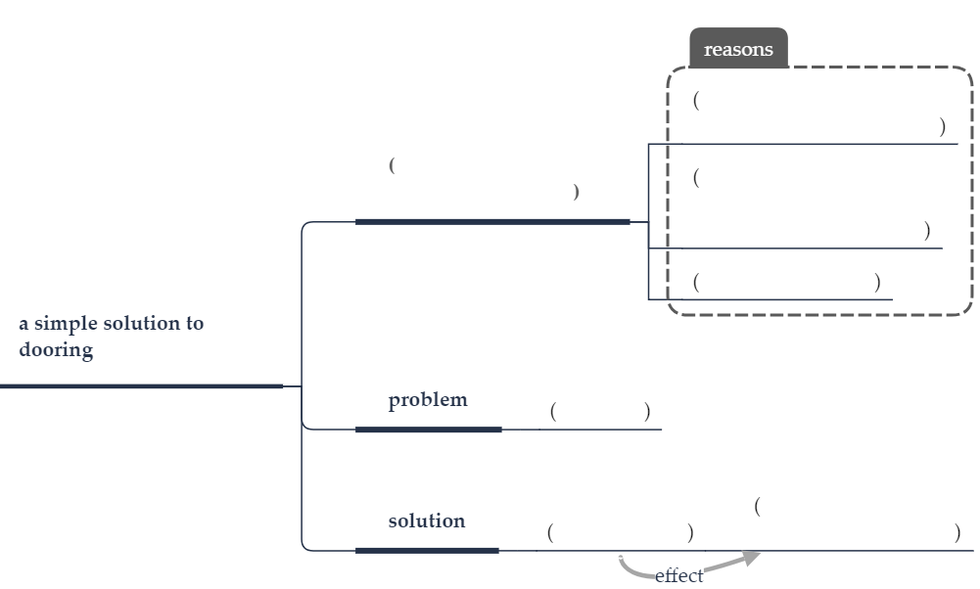

Text 2

I. summarize each paragraph in one sentence or phrase

|  |  |
| --- | --- |
| Text | Summary |
| FDA Commissioner Scott Gottlieb recently proposed new limits on sales of many fruit- and candy-flavored e-cigarettes. If the new rules are adopted, convenience stores and gas stations won’t be able to sell them unless they set up separate rooms that bar entry to anyone under 18. |  |
| This is meant to stop the indiscriminate sales that have helped enable an alarming 3.6 million high school and middle school students to vape in 2018. And it is a step in the right direction. But it’s hardly the crackdown that the Food and Drug Administration is making it out to be. |  |
| One problem is that mint, menthol and tobacco-flavored e-cigarettes will go on being sold much as before — and underage vapers enjoy these flavors, too. |  |
| Another is that the FDA’s draft guidance moves too slowly. It calls for makers of sweet-tasting vapes to apply for FDA approval by August of 2021. That’s one year sooner than the deadline for other e-cigarettes — but three years later than it would have been had Gottlieb not extended the legal deadline soon after he became commissioner. The extra time that e-cigarettes were allowed to grow their market free of FDA regulation has contributed to today’s youth vaping epidemic. |  |
| At this point, more strenuous action is needed to protect children and adults from known and suspected dangers of e-cigarettes, many of which are only beginning to be understood. The sale of fruit- and candy-flavored products should simply be banned. And all remaining e-cigarettes should be regulated as tightly as combustible cigarettes are. The FDA should constrain their advertising, and require that their ingredients be listed on the package by quantity. |  |
| In addition, the nicotine content of e-cigarettes should be limited — as it is in Europe. Nicotine is what hooks people on smoking, and new American vapes often provide a greater hit of the substance than ordinary cigarettes do. Gottlieb himself has championed lowering the nicotine content of combustible cigarettes to non-addictive levels. The nicotine in vapes is at least as big a problem. |  |
| Gottlieb is leaving the FDA next month. During his two years in the job, he has spoken out forcefully in favor of restricting access to e-cigarettes — but his actions have been anything but forceful. Ned Sharpless, who will soon be the agency’s acting head, should move faster to protect Americans from this growing public health problem. |  |

II. What is the issue?

III. Mind-map

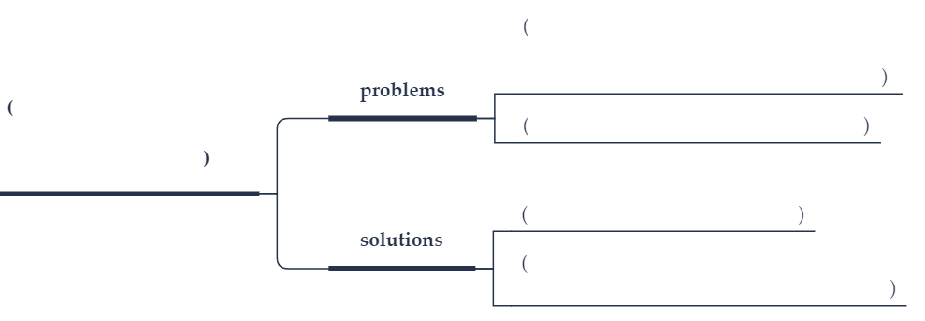

Text 3

I. summarize each paragraph in one sentence or phrase

|  |  |
| --- | --- |
| Text | Summary |
| For the first time in recorded history, fewer than 1 in 10 people are living in “extreme poverty,” according to a new World Bank report. Just four decades ago, more than 4 in 10 people lived at such an income level, which the bank defines as less than $1.90 a day. This progress has been so steady that many experts now ask if a zero level of extreme poverty could soon be possible. |  |
| The reason for such speculation is that so many countries have lifted people out of the worst of living conditions that the world may have crossed a mental threshold. As more of the poor learn their plight is not inevitable, attitudes shift. According to poverty expert Esther Duflo, the anticipation of future poverty has long exacerbated current poverty. Yet with more reports of progress, the task of alleviating poverty gets easier. |  |
| The current goal of the World Bank and many other aid agencies is to have only three percent of people living in extreme poverty by 2030. About half of the world’s countries have already achieved that rate. Much of the progress over the past quarter century has been in Asia, especially China, India, and Indonesia. |  |
| In 2000 the world’s countries agreed on a goal to cut poverty to half of the 1990 level by 2015. This collective effort generated so much innovation and cooperation that the goal was reached at least five years early. Someone now escapes extreme poverty every 1.2 seconds, according to one estimate. |  |
| Much of today’s poverty is now concentrated in sub-Saharan Africa. While its rate has fallen to 41 percent from 54 percent since 1990, the actual number of people in extreme poverty has risen because of high population growth. And just two countries in Africa, Nigeria and the Democratic Republic of Congo, will be home to 44 percent of people living in extreme poverty by 2050 if trends continue, according to the Bill & Melinda Gates Foundation. |  |
| Solutions to poverty are both well known and widely disputed, but the World Bank focuses on what it calls “human capital,” or raising up the education and health standards of the poor, with a special focus on women and girls. |  |
| With each new report on the material progress of the poor, the world must also celebrate something deeper. A rise in expectations among the poor about their future is really a realization about their latent capabilities. Awakening those capabilities will help humanity more quickly achieve the goal of no people living in extreme poverty. |  |

II. What is the issue?

III. Mind-map

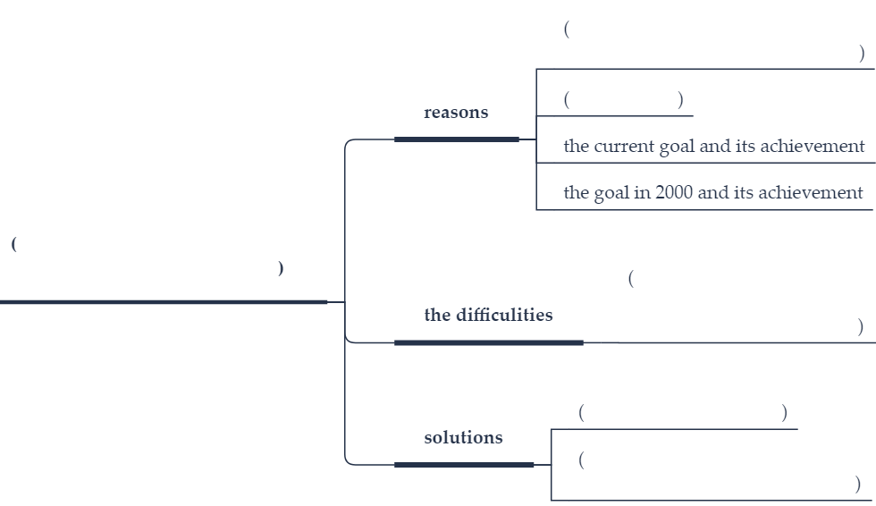

Text 4

I. summarize each paragraph in one sentence or phrase

|  |  |
| --- | --- |
| Text | Summary |
| Americans may be largely unaware of the extreme and pervading dangers facing American Indian and Alaska Native women. According to a National Institute of Justice study, more than half have been sexually assaulted. More than a third have been raped — a proportion more than double that of white women. For girls and young women aged 15 to 24, homicide is the third leading cause of death. And thousands of American Indian and Alaska Native women and girls have simply gone missing. |  |
| It is a crisis that has been too long ignored. The federal government funds police services, criminal investigation, tribal courts and more. But the assistance has been stretched too thin to bring crimes against women under control. |  |
| One underlying problem is that many tribal law enforcement agencies are severely understaffed, yet need to police vast territories. The Navajo reservation has fewer than 200 police officers and 30 criminal investigators. That’s a police-to-population ratio significantly lower than the national average. Yet the reservation’s murder rate is many times higher than the average. |  |
| Another problem unique to tribal law enforcement is jurisdictional confusion. A crime on or near reservation land can cross the desk of tribal officers, local police, and state police, leading to delays and miscues in investigations. In one instance in 2016, when a girl was kidnapped in New Mexico, poor coordination among police authorities led to an eight-hour delay in action. |  |
| Outside of reservations, too, American Indian and Alaska Native women face extraordinary danger. Many who live in cities end up missing or killed, and city police departments often do a poor job of tracking them. A study by the Urban Indian Health Institute identified 153 missing or dead women whose cases did not exist in law enforcement records, and cited more than one police department whose reports combined American Indians and Indian-Americans. Until they have good data on the violence done to American Indian and Alaska Native women, police will struggle to end it. |  |
| Senators Lisa Murkowski and Catherine Cortez Masto have just reintroduced legislation to focus attention and resources on the problem. Named “Savanna’s Act” in honor of Savanna LaFontaine-Greywind, a 22-year-old who was murdered in North Dakota in 2017, the bill would require, among other things, annual consultations between U.S. attorneys and Indian tribes on sexual violence, training and technical assistance for tribal police, and new rules for reporting and sharing crime data and responding to violent crimes. In addition, last week Senator Jon Tester of Montana proposed a bill directing the Government Accountability Office to review federal agencies’ response to the crisis and to recommend solutions. |  |
| These would be modest first steps toward improving relations between tribal authorities and state and federal law enforcement, gathering crucial crime data, and funding tribal government efforts to protect indigenous women and girls. Congress should pass the legislation without delay. |  |

II. What is the issue?

III. Mind-map

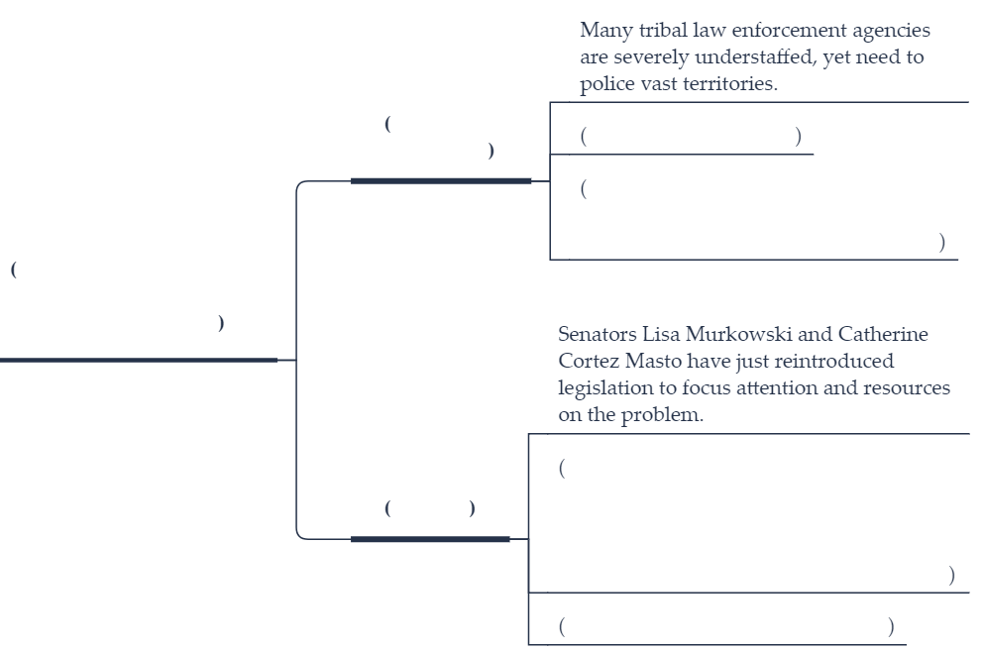

Text 5

I. summarize each paragraph in one sentence or phrase

|  |  |
| --- | --- |
| Text | Summary |
| THE DEBATE over data privacy has bring Facebook and Google to a harsh spotlight, while the least acceptable actors in the information economy have managed to stay offstage. That is no surprise, since hiding is at the core of data brokers’ business. |  |
| Data brokers, who prefer to be called by the apparently more flattering title of “information resellers,” deal in information on consumers with whom they have no direct relationship and to whom they provide no service. Sometimes, brokers use that information to run people-search sites: You put in a phone number, and you get a name or address. Sometimes, they use it for marketing, assembling detailed reports on consumers and allowing advertisers to target their products to specific demographics. The collection occurs, with the help of telecommunications companies and unreliable smartphone apps passing along location data and more, with most Americans totally unaware. |  |
| This is disturbing in principle and dangerous in practice: Brokers classify consumers in categories such as “Ethnic Second-City Strugglers” and “Tough Start: Young Single Parents” so that companies can market them risky financial products such as high-cost loans. A prospective employer could access a candidate’s health history, or Internet searches that point to potential medical conditions, and decide not to hire. Data brokers’ security practices are not monitored, either, which means the data they collect can easily fall into the hands of hackers with even worse motives. |  |
| To fix this problem, Congress should include in any federal privacy framework a registry of data brokers. A vigorous privacy regime should impose limitations on what companies across industries can do with consumer data. It should grant consumers the right to access, correct and delete their information. But even with those safety guards in place, data could still reach brokers, and any new rights would be worth little, if Americans remain powerless to exercise those rights because they do not know who the brokers are. |  |
| This registry, administered by the Federal Trade Commission, would offer consumers a one-stop shop for tracking down their data — and seeking redress when it has been abused. Americans could also enroll with a single click in a “do not track” list that would keep their information out of broker databases. The tech giants at the center of the privacy controversy have done much to earn the suspicion of consumers and politicians. But their size and prominence also makes them easy targets. Congress should pay attention to those that are harder to spot, too. |  |

II. What is the issue?

III. Mind-map

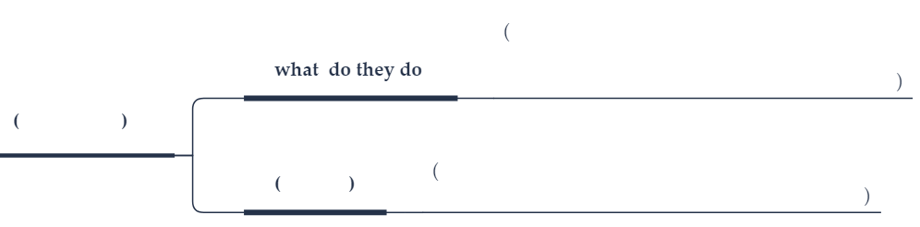

Text 6

I. summarize each paragraph in one sentence or phrase

|  |  |
| --- | --- |
| Text | Summary |
| In his State of the Union speech earlier this month, President Trump touched briefly on an area where he and Democrats could easily make common cause for the sake of the country: infrastructure. Yet by skipping over the details he missed an important opportunity to connect his rhetoric of greatness to something tangible, impactful and transformational. |  |
| The omission is particularly striking when you consider what the right kind of infrastructure program could do for rural America, a core part of Trump’s base. While metropolitan America surges forward, rural areas continue to be divided by demographic decline, loss of manufacturing jobs, rising poverty, drug abuse, insufficient capital, poor infrastructure and a low participation rate in the global digital economy. |  |
| Urgent infrastructure needs are placing a severe drag on the prospects of rural America and deepening the rural-urban divide. These communities desperately need school renovations, upgrades to water and sewage treatment systems, and improved transit to metropolitan centers. |  |
| Such improvements will, of course, take plenty of time, effort and money. But there’s one area where decisive action could have positive effects relatively quickly: the digital economy. The lack of broadband Internet connectivity is the trouble of many rural areas, exacerbating demographic decline by contributing to out-migration of millennials and loss of business opportunities. |  |
| The United States ranks low in comparison with other industrialized nations in broadband connectivity, and this is a particularly acute problem in rural areas, where 39 percent of people (more than 24 million Americans) lack high-speed Internet. (In urban communities, the figure is 4 percent.) |  |
| Providing broadband to rural have-nots will boost economic growth; Federal Communications Commission Chairman Ajit Pai has called it a “game-changer for rural Americans.” Several studies have shown the introduction of broadband connectivity correlates favorably with increasing job growth and economic productivity gains. For example, a 2016 World Bank report found GDP per capita growth is 2.7 percent to 3.9 percent higher after the introduction of broadband; every 10 percentage point increase in fixed broadband household penetration increases GDP per household by 0.77 percent. Transformative broadband investments will provide an economic stimulus, enabling Trump to deliver on his promise to lift up the “forgotten people” in his base. |  |
| Yet merely installing high-speed fiber-optic networks across rural America, while vital, will not be enough. Significant public and private investment in K-16 education is required to build a new digital economy future for rural America. In addition, innovative public-private partnerships, including university-community-industry-partnerships (UCIPs) can motivate action around the urgency of digital literacy in rural areas. Key to this strategy would be significantly increasing participation in expanded coding and STEM programs from K-16 as well as vocational and workforce development programs. |  |

II. What is the issue?

III. Mind-map

